**Issues raised include:**

|  |  |  |
| --- | --- | --- |
|  | **Issue** | **Response** |
| **1** | Language selection is hidden: selection feature should come immediately after login. | You noted that this is a big overhaul. We may ignore the comment. |
| **2** | View reports feature should not be for every user. Let users access reports which they supposed to. This should apply to other modules. | Needs adjustment. Refer to attached scenarios doc. |
| **3** | Implement one module to completion including all processes | Selected the process of making a requisition. See its attached d data flow for implementation. |
| **4** | Reports are poorly presented and formatted. Design one representative report the way it is currently being used. | Picked a health unit outpatient monthly for i**) essential drugs, vaccines and ii) consumption contraceptives data.** See attached structure. |
| **5** | Form data does not clear when submit button is clicked | Needs adjustment. |

**Requisition and delivery process monitoring**

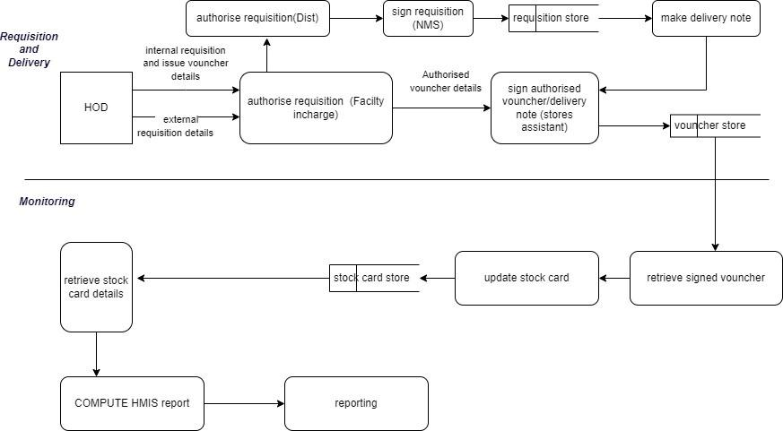

**Health Unit Outpatient Monthly report**

1. **HMIS FORM 105: HEALTH UNIT OUT PATIENT MONTHLY REPORT: ESSENTIAL DRUGS, VACCINES AND CONTRACEPTIVES**

**1.1 STOCK-OUTS**

Note: Out of stock means that there was NONE left in your health unit STORE

|  |  |  |  |  |
| --- | --- | --- | --- | --- |
| Enter the number of stock out day for the following tracer items (in order for the HSD and DHT to follow up the issue) | | | | |
| Name | | Tick if out of stock | No. of days of stock out | |
| HSSP indicator item: Tracer Medicines found in all level of health facilities (HCII to Hospital) | | | | |
| First line drug for malaria | |  | |  |
| Quinine tabs | |  | |  |
| Cotrimoxazole | |  | |  |
| ORS sachets | |  | |  |
| Measles Vaccine | |  | |  |
| Fansidar | |  | |  |
| Depo-Prover | |  | |  |
| To be filled by all health Facilities offering HIV/AIDS and TB treatment | | | | |
| HIV Testing kits | Screening |  |  | |
| Confirmatory |  |  | |
| Tie-breaker |  |  | |
| ARVS first line | AZT/3TC/NVP |  |  | |
| AZT/3TC |  |  | |
| TDF/3TC |  |  | |
| FTC |  |  | |
| NVP |  |  | |
| EFV |  |  | |
| 1st line Anti TB medicine | HRZE |  |  | |
| EH |  |  | |
| RH |  |  | |

|  |  |  |  |  |  |
| --- | --- | --- | --- | --- | --- |
| Add the name of other drugs, vaccines, contraceptive or  Supplies tat suffered a stock out during the month | | | | | |
| Number of Days of Stock out | | | | | |
| No. | Name | DOS | No. | Name | DOS |
| 1 |  |  | 21 |  |  |
| 2 |  |  | 22 |  |  |
| 3 |  |  | 23 |  |  |
| 4 |  |  | 24 |  |  |
| 5 |  |  | 25 |  |  |
| 6 |  |  | 26 |  |  |
| 7 |  |  | 27 |  |  |
| 8 |  |  | 28 |  |  |
| 9 |  |  | 29 |  |  |
| 10 |  |  | 30 |  |  |
| 11 |  |  | 31 |  |  |
| 12 |  |  | 32 |  |  |
| 13 |  |  | 33 |  |  |
| 14 |  |  | 34 |  |  |
| 15 |  |  | 35 |  |  |
| 16 |  |  | 36 |  |  |
| 17 |  |  | 37 |  |  |
| 18 |  |  | 38 |  |  |
| 19 |  |  | 39 |  |  |
| 20 |  |  | 40 |  |  |

*This refers to the drug recommended in the National policy at the time

**1.2 CONSUMPTION DATA**

Please indicate the total number of doses consumed for each category of drugs under the respective age group.

|  |  |  |  |  |  |
| --- | --- | --- | --- | --- | --- |
| Drug item | 4months-3yrs | 3+ - 7yrs | 7+ - 12yrs | 12+ | TOTAL |
| No. of Yellow ACT doses dispensed |  |  |  |  |  |
| No. of Red ACT doses dispensed |  |  |  |  |  |
| No. of Brown ACT doses dispensed |  |  |  |  |  |
| No. of Green ACT doses dispensed |  |  |  |  |  |
| Quinine |  |  |  |  |  |
| Cotrimoxazole tabs |  |  |  |  |  |
| Amoxycilin Capsule |  |  |  |  |  |
| ORS sachets |  |  |  |  |  |
| Measles Vaccine |  |  |  |  |  |
| Fansidar |  |  |  |  |  |
| Depo-Provera |  |  |  |  |  |

1. **Daily Dispensing Log**

|  |  |  |
| --- | --- | --- |
|  | **Daily dispensing log fields** |  |
| 1 | Health unit name |  |
| 2 | Date |  |
| 3 | OPD/IPD number |  |
| 4 | NIN |  |
| 5 | Names and quantity of medicine dispensed |  |
| 6 | Prescriber |  |
| 7 | Dispenser |  |
| 8 | Balance brought forward |  |
| 9 | Amount received |  |
| 10 | Total dispensed |  |
| 11 | Balance at hand (B/F+ amount received – total dispensed ) |  |
| 12 | Comment |  |

1. **Requisition and Issue Voucher/ Details**

|  |  |  |
| --- | --- | --- |
|  | **Requisition log fields** |  |
| 1 | Health unit name |  |
| 2 | Dept./section/ward/dispensary |  |
| 3 | Date |  |
| 4 | Order by (name, title and signature) |  |
| 5 | Authorised by(name, title and signature) |  |
| 6 | Item code number |  |
| 7 | Item description(name, formulation, strength) |  |
| 8 | Previous receipt |  |
| 9 | Balance on hand |  |
| 10 | Quantity required |  |
| 11 | Quantity issued |  |
| 12 | Batch No |  |
| 13 | Issue date |  |
| 14 | Receipt date |  |
| 15 | Name, title and signature |  |
| 16 | Name and signature |  |

1. **Stock card**

|  |  |  |
| --- | --- | --- |
|  | **Fields** |  |
| 1 | Health unit name |  |
| 2 | Health unit code(health facility no. Assigned by moh) |  |
| 3 | Item description(name, formulation, strength): | Pack size, item code No. |
| 4 | Special storage conditions : |  |
| 5 | **Unit of issue:** | Date, to or from |
| 6 | AMC: | Voucher number, quantity in |
| 7 | **Maximum stock level:** | Quantity out, losses/adjustments, balance on hand |
| 8 | **Minimum stock level:** | Expiry date, Batch No., remarks, initials |

1. **Invoice / delivery note**

|  |  |  |  |
| --- | --- | --- | --- |
|  | **Fields** |  | |
| 1 | Deliver to: | Health facility details | |
| 2 | Client no.(health facility no. Assigned nms) |  | |
| 3 | Client reference |  | |
| 4 | Order No. |  | |
| 5 | Journey No. |  | |
| 6 | Shipment date |  | |
| 7 | Printed by |  | |
| 8 | Program |  | |
| 9 | No. of cartons |  | |
| 10 | Remaining budget |  | |
| 11 | Item Code |  | |
| 12 | Description |  | |
| 13 | Quantity (no. Of packages) |  | |
| 14 | UOM(no. of items eg capsules in a package) |  | |
| 15 | Expiration |  | |
| 16 | Lot |  | |
| 17 | Unit price |  | |
| 18 | Total |  | |
|  | The receiver acknowledges that the above goods have been received in good condition | | |
| 19 | Approved by: | | Goods received by: name , title, signature and date |
| 20 | Date printed | | Receipt witnessed by: name , title, signature and date |
| 21 | Delivery by | |  |